SCC Health Check Management Pack
The MP contains 28 reports which are required to run on the Datawarehouse or the Operational Database. You need to create a custom Shared Datasource on your report server to be able to run the reports on the Operational Database.
Report Name | Queries Database
Agents - Agent Hotfix Report (OM) | OperationsManager
Agents - Agents Missing Hotfix Report (OM) | OperationsManager
Agents - Down Agents (OM) | OperationsManager
Alerts - Alerts Closed by Specific User (DW) | OperationsManagerDW
Alerts - Alerts Closed by User [Count] (DW) | OperationsManagerDW
Alerts - Alerts Closed by UserID (DW) | OperationsManagerDW
Alerts - Number of Alerts per Day (OM) | OperationsManager
Alerts - Top 20 Alerts By Alert Count (OM) | OperationsManager
Alerts - Top 20 Alerts By Repeat Count (OM) | OperationsManager
Config Churn - Discoveries Last 24 Hours (DW) | OperationsManagerDW
Config Churn - Modified Properties Details Last 24 Hours (DW) | OperationsManagerDW
Events - All Events Count By Last 7 Days (OM) | OperationsManager
Events - Most Common Events by Number and Publisher (OM) | OperationsManager
Events - Top 20 Computers Generating the Most Events (OM) | OperationsManager
Misc - Groups Report (OM) | OperationsManager
Misc - Infrastructure Overview (OM)  Misc - Management Packs (OM)  Misc - Operational and Datawarehouse Usage Report (OM) - (DW)  Misc - Outage and Maintenance Report (DW)  Misc - Run As Profiles (OM)  Performance - Performance Inserts Per Day (OM)  Performance - Top 20 Computers By Perf Count (OM)  Performance - Top 20 Performance Insertions By Perf (OM)  Performance - Top Performance Baseline Generating Rules (OM)  State - Noisiest Monitors (OM)  State - Old State Changes Not Groomed (OM)  State - State Changes Per Day (OM) | OperationsManager  OperationsManager  Both  OperationsManagerDW  OperationsManager  OperationsManager  OperationsManager  OperationsManager  OperationsManager  OperationsManager  OperationsManager  OperationsManager

Installation
Before we can start by importing the management you need to create a custom Shared Datasource on your reporting server.
Simply logon to your reporting server and go to http://localhost/reports
In the root of the reporting website click details on the right side. You will now see the Datasource for the reporting server called Data Warehouse Main.
Look at its properties and take note of the connection string details we going to need it when designing our custom datasource.
data source=”<ServerName>”;initial catalog=OperationsManagerDW;Inegrated Security=SSPI
Go back to the root of the reporting website http://localhost/reports and select New Datasource.
Now fill in the details (see screen print) pay close attention to its name this needs to be OperationalDataBaseMain
Also make sure you are connecting to the appropriate server if your Ops DB is located on another server you need to change the connection string appropriatly like:
data source=test01
data source=test01\customSQLInstance
As for the initial catalog this is the Name of the Ops DB which is default OperationsManager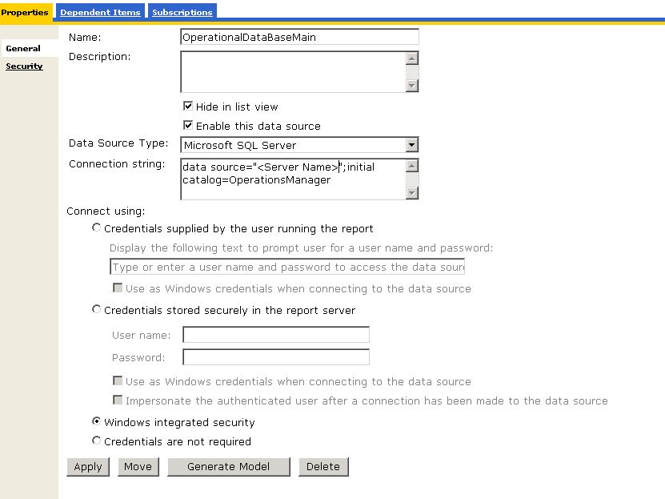
Also be ware to check Windows Integrated security
After adding the datasource you can simply import the MP and start running reports. The datasource is required to query the Ops DB which is not supported by Microsoft and therefore no datasource is present.

Know Issues:
"An error occurred during client rendering. An error has occurred during report processing. Cannot create a connection to data source 'OperationalDataBaseMain". For more information about this error navigate to the report server on the local server machine, or enable remote errors."
This error has been reported by several users. The procedure for resolving this issue:
Instead of ” Windows Integrated Security” select “Credentials stored securely in the report server and use windows creds when connecting to the data source” Fill in the Service account used for SQL/SCOM for the data warehouse. This fix has been reported by several users.

